**Direct Matrix Converter Based on Space Vector Modulation for Standalone Systems**

Clara1 and Mia2

*Department of Electronic Engineering, Middlesex University, London*

*1Corresponding Author: claramsu@gmail.com*

***To Cite this Article***

*Clara and Mia, “Direct Matrix Converter Based on Space Vector Modulation for Standalone Systems”, Journal of Computational Intelligence and Secure Systems of Artificial Intelligence, Vol. 01, Issue 01, May 2025, pp:01-05,*

*Submitted: xx-xx-xxxx Accepted: xx-xx-xxxx Published: xx-xx-xxxx*

*_____________________________________________________________________________________________*

***Abstract****: In this paper we employ the Permanent Magnet Synchronous Generator (PMSG) for standalone wind power generation because it offers high efficiency combined with minimal maintenance requirements. A direct matrix converter based on smart technology functions as the power conversion interface to create output waveforms that are sinusoidal with limited higher order harmonics while having no subharmonic components. The system removes the requirement for dc-link and all other passive equipment. By using certain switching states Space vector modulation controlled (SVM) matrix converter switching has the potential to minimize switching losses. The proposed work stands as a potential design concept for future variable speed drive technology. The suggested model for an RL load underwent evaluation through MATLAB simulation by changing the resistor and inductance values.*

***Keywords****: SVM-space vector pulse modulation, wind-energy conversion system (WECS), and permanent-magnet synchronous generator (PMSG)*

*This is an open access article under the creative commons license* [*https://creativecommons.org/licenses/by-nc-nd/4.0/*](https://creativecommons.org/licenses/by-nc-nd/4.0/) **

*_____________________________________________________________________________________*

1. **Introduction**

Wind Energy Conversion Systems stand as one of the top energy production methods in renewable energy fields including biomass alongside wind and solar and hydropower because they offer straightforward implementation. The operation of wind turbines avoids emissions produced during the production of non-replaceable thermal power and nuclear power systems [1-2]. The technology includes systems which operate independently to deliver pumping functions for irrigation water systems as well as remote power generation and grid connection capabilities. Within wind-driven generator technology there are three core categories: Fixed speed, variable speed wind turbines and induction generators. Two generator types namely DFIG and PMSG function either in fixed speed operation or variable speed operation per research conducted in [2].

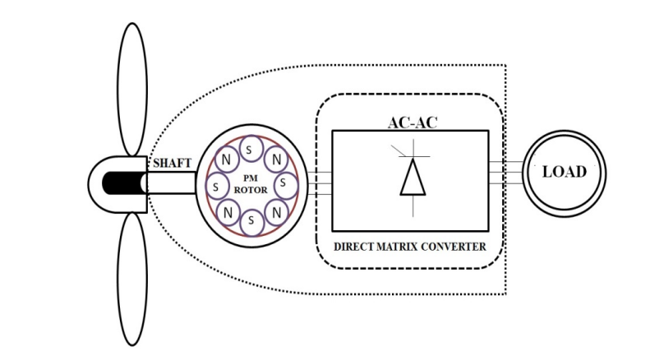

Fig 1: Circuit Diagram of the Proposed Method

1. **Matrix Converter Directly**

The direct matrix converter shown in Figure 2 represents a direct AC-AC converter system that brings multiple advantages compared to traditional inverters. This device features an intrinsic dual-directional power flow capability which generates waveforms with sinusoidal signals while maintaining low harmonic content and eliminating sub-harmonic frequencies and enables comprehensive input power factor management. The device's minimal energy storage requirement eliminates the necessity of employing large energy-storing capacitors and

1. **SVM for Direct Matrix Converter**

The method uses controlled lengths of legitimate three-phase null states from a matrix converter to develop necessary sinusoidal output voltages combined with inverter output control through space vector modulation. The representation of all functional switching states in a matrix converter takes place through voltage space vectors. Implementation of the SVM method requires selecting switching vectors plus calculating vector on-time values as its two essential sequential steps. The three-phase matrix converter includes 27 distinct switch combinations that result in 27 voltage vectors available for selection. The 27 possible switch combinations of matrix converters divide into three distinct groups. There are three different vector types including zero vectors and stationary vectors and synchronously spinning vectors.

|  |  |  |
| --- | --- | --- |
| S.no | Type | Converter |
|  |  |  |
|  |  |  |
|  |  |  |
|  |  |  |

Table 1: Matrix converter

1. **Simulation and Results**

The control systems based on space vector modulation for PMSG-fed resistive and inductive loads operate through AC-to-AC matrix converters and their MATLAB/Simulink model implementations are shown in Figure 5. When PMSG serves as a power source the modelling approach is implemented [2]. The model design implementation used equations from (9) through (20) under a 12 m/s wind speed condition. The PMSG Simulink model appears in figures 6 and 7.

1. **Conclusion**

The research demonstrated space vector modulation techniques used to analyze comparative effects between various resistances and inductances. The addition of energy storage components to the RL load becomes unnecessary whenever PMSG operates with a direct AC-AC matrix converter [1-2]. Among all PWM techniques SVPWM demonstrates superior performance. The PMSG modelling requires 12 m/s as its minimum wind velocity for analysis. Matrix converters replace traditional DC-links to achieve high efficiency alongside low-cost operation. Future research efforts will expand extensively to develop modelling techniques for variable speed drives based on agricultural motors alongside water pumping mechanisms.

**References**

1. Chie Lee and Yadav Kumar. “An Matrix Converter using Array System in Power Electronics in Communication Systems”. Springer Conference in Hindustan University, Chennai, VOL. 2, NO. 3, March 2009
2. Saritha, Srikanth, Subhakar and Sunitha, “A Process control system in Industrial Applications using Thyristors in power electronics for PMSG”,”. Elsevier 2011. China, 7 – 9, January 2012.
3. Niharika, Lakshman Reddy and Shanchie, “A Novel of MIMO concepts in wireless relay networks in Space Time and Space Frequency in achieve diversity”, ” IEEE Conference Proceedings on Innovative Research in Communication Systems (IRCS), International Conference. vol. 2, pp. 67 – 75, January. 2010
4. John Diesel, Shang Chee and Cooper Lee, “Standalone Grid system for On and OFF modes Using Renewable energy sources using PMMC Technology’, ”Springer Proceedings on Green Energy on World environmental Day”, IEEE conference proceedings held at Madras University, on the 20tt Century. pp.10-19, 2020
5. F Max Savio, M Sasi Kumar. “An Effective Control Technique for an Impedance Source Inverter Based Wind Energy System”. 2012 IEEE International Conference on Emerging Trends in Electrical Engineering and Energy Management (ICETEEEM-2012)
6. Sasikumar M and Chenthur Pandian S. “Characteristics Study of ZSI For PMSG Based Wind Energy Conversion Systems”. Journal of Electrical Engineering (JEE). ISSN: 1582-4594.